WPD1 design (1.9 – 6.5GHz)
Table 1. Trace width and length for WPD1(Updated value)
Z0(90 degree) | W(mil) | L(mil)
52.73 | 38.40 | 4.1807e+02
62.64 | 27.88 | 4.2296e+02
79.82 | 16.375 | 4.3013e+02
94.83 | 10.25 | 4.3472e+02
50 | 42 | **

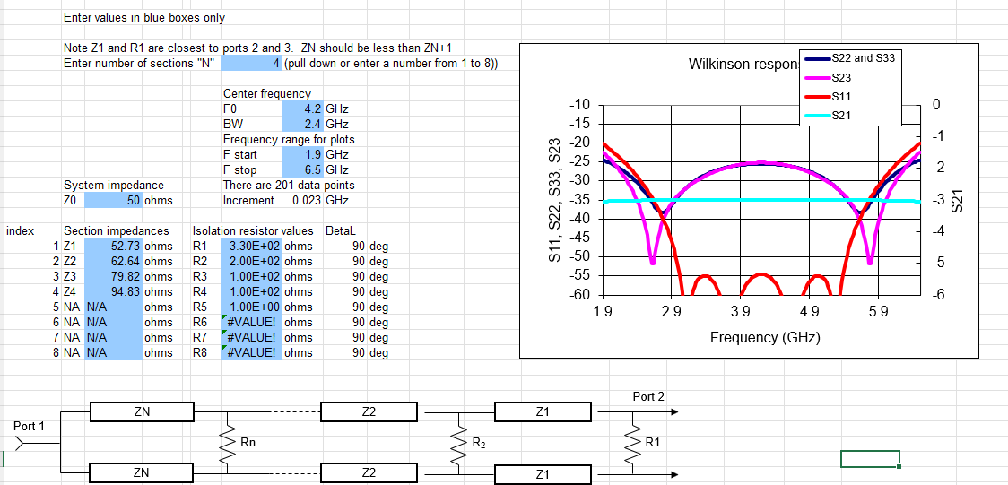
Figure 1. WPD1 parameters (update)
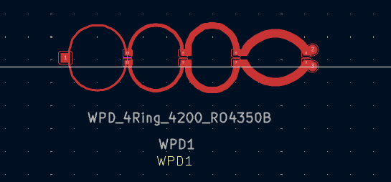
Figure 2. WPD_4Ring_4200_RO4350B (In PDG footprint)

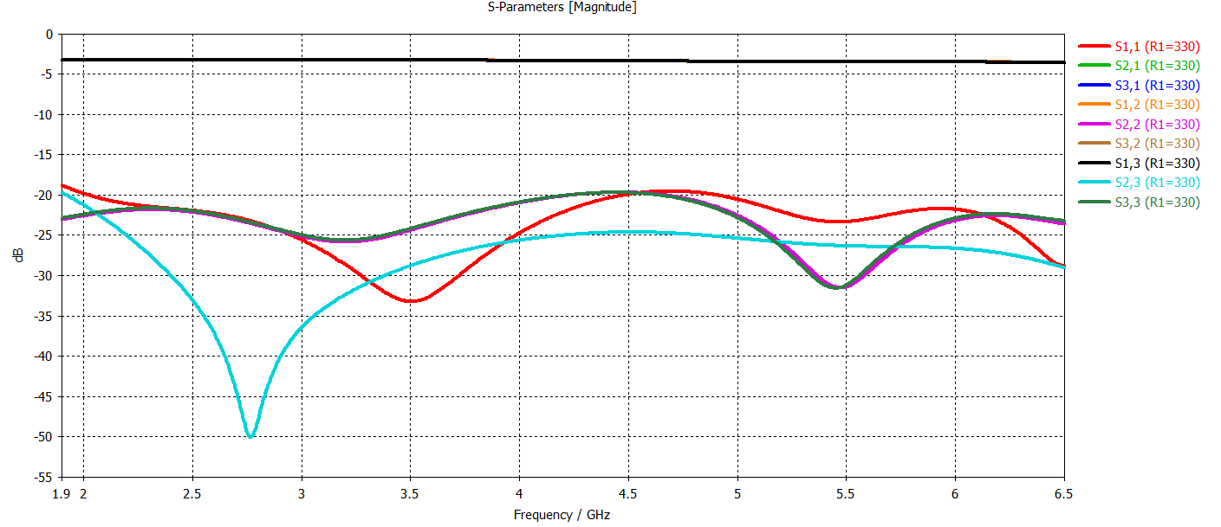
Figure 3. CST simulation with R1 =330, R2 = 200, R3 = 100, R4 = 100

